**Love in Action**

**Reading: Luke 10:25-28**

One day an authority on the Law stood up to test Jesus. “Teacher,” he asked, “what must I do to receive eternal life?”

What is written in the law?” Jesus replied. How do you understand it?”

He answered, “Love the Lord your God with all your heart and with all your soul. Love him with all your strength and with all your mind. And love your love your neighbour as you love yourself.”

“You have answered correctly,” Jesus replied. “Do that, and you will live.”

**Thought about the reading**

What has Jesus done for us? We know that he loves us. At Easter, we remember that because he loves us, he died for us so that we can be forgiven. Because he died for us, we can become part of God’s family.

When we think about what he has done for us, we want to say ‘Thank you’ to him. We want to show him that we are thankful. How can we do that? Jesus said that we do that by loving him with all our heart, soul, strength and mind, with everything we are. We want to live our lives in a way that pleases him.

Jesus said that if we loved God, then we would also love our neighbour. He went on to tell the story of the Good Samaritan, who helped someone who was beaten up by robbers and left for dead. The Samaritan’s neighbour was someone who needed help, even though the Samaritan did not really know him. This is love in action. Jesus said that we should do the same.

Our love for God and our neighbours is not the same as the love we might have for our boyfriend or girlfriend, or our husband or wife. This is called romantic love. Christian love is like the love Jesus has for us, that is willing to give everything to help those who need it. This sounds hard, but Jesus gives us his Holy Spirit to help us love him and our neighbours.

**Prayer**

Dear Jesus, thank you for everything you have done for me. Thank you for dying for me, so that I can be forgiven and become a child of God.

I want to love you in return. Please help me to love you and to love my neighbour as you told me to. Show me how to put love into action.

Amen

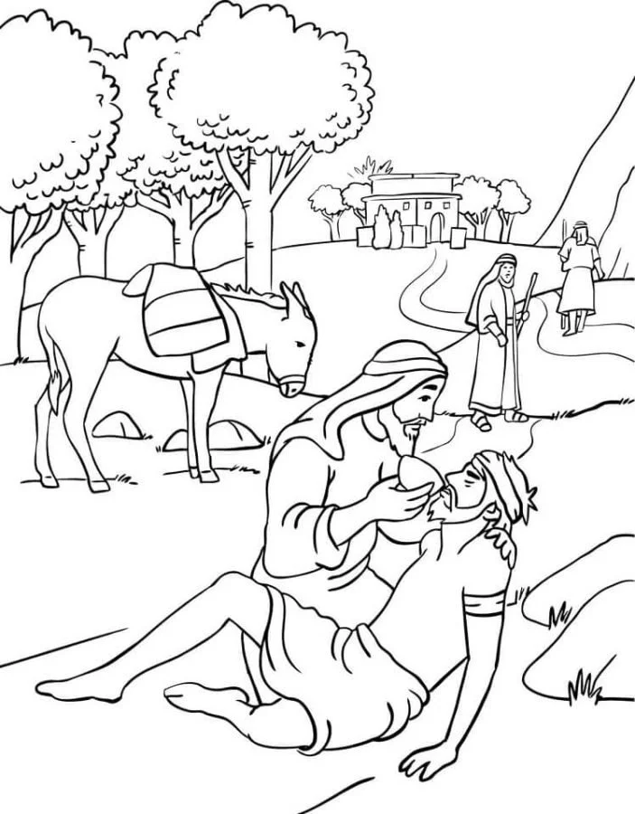

**Cambridge Causeway**

Summer 2025

Bible Study notes

**How Jesus wants us to live**

1. **Love in action**

By Chrissy Cole